Theodore Jagodits/ MA 331/ HW#4

I pledge that I have abided by the Stevens Honor System.

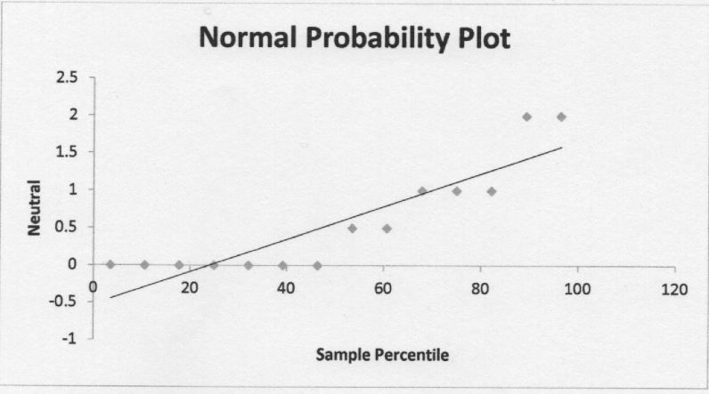for 7.71a

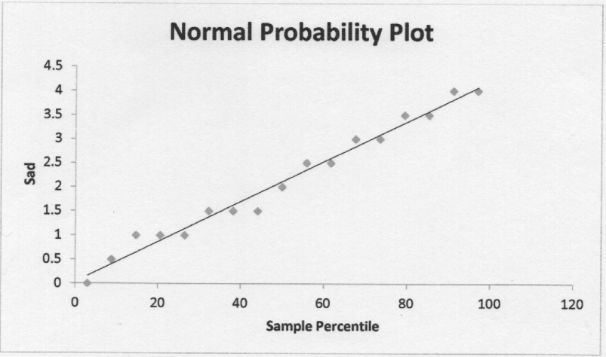for 7.71a

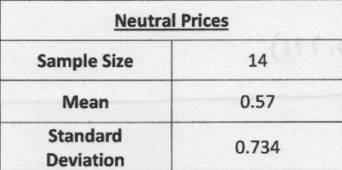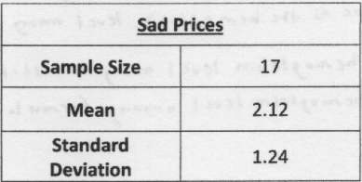for 7.71b

